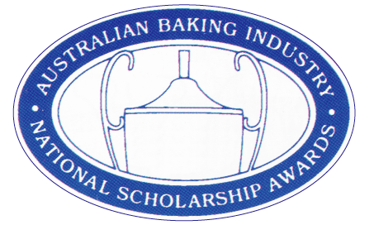
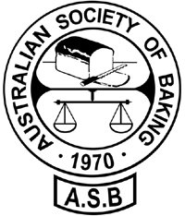

The Australian Baking Industry
National Scholarship Awards

2023 ACHIEVER’S LIST

The Australian Society of Baking, in conjunction with Scholarship Partner, EOI, is delighted to congratulate the following competitors on their achievements in this year’s Australian Baking Industry National Scholarship Awards -

Regional Scholarship Winners
Sydney J Packham Baking Industry Medal
Rebecca Tracey – CJ’s Bakery, SA - Western Region
Brianna Foster – Uprising Bakery, NSW - Eastern Region
Caleb Braszell – Baker Bleu, Vic – Southern Region

Arthur E Denison Trophy
Ganesh Iyer – Riviera Bakery, SA - Western Region
David Damour – CIT TAFE, ACT - Eastern Region
Hannah Quick – Tinto Bakery, Vic – Southern Region

All Regional winners will travel to Brisbane on October 8th for their 5 day/ 4 night “Scholarship adventure” with the National Champion in each category being announced at the ASB Chairman’s Dinner on October 11th at the Rydges Hotel South Brisbane.

Certificates of Excellence
Sydney J Packham Baking Industry Medal
Connor Beisler - Dungog Barrington Bakery, NSW

Certificates of Excellence
Arthur E Denison Trophy
Sabrina Lim - AEGIC - NSW
Russell Lecomte - Sky Casino - SA
Glen Stoddart - Kimbercrust Bakery - WA
Kerry Yacoumis - Tasty Bakery -SA

II

The Australian Baking Industry
National Scholarship Awards
(Cont’d)

Notes: 1. Certificates of Excellence will be posted out in mid November.
2. Competitors wishing to obtain “feedback remarks” from the Judges may do so by phoning Janet Blythman during W/C November 8th, between 10.30 am & 12.30pm (see contact details below)

Once again, CONGRATULATIONS to all the 2023 Scholarship Achievers!

Cherrie Wilson; Janet Blythman; Jake Lowing;
Lindsay Weber; Leo Mato; Craig Perry

(The ABINSA’s Scholarship steering committee)

Tuesday, September 18, 2023

Event Partner: Gold Sponsors: Supporting Sponsors: Presented By:
Peerless EOI Allied Pinnacle Novozymes Australian Society of Baking Intralox Australian Bakels
Mauri Bake Skills Australia
National Baking Industry Association

Janet Blythman’s Contacts: Post: PO Box 16, Bribie Island Qld 4507 E: austsbaking@gmail.com P or Txt: 0467 922 333

